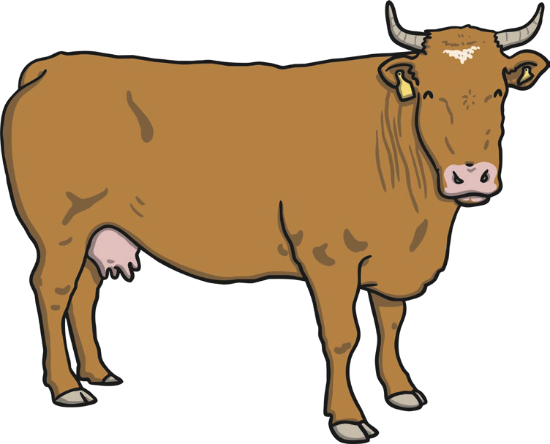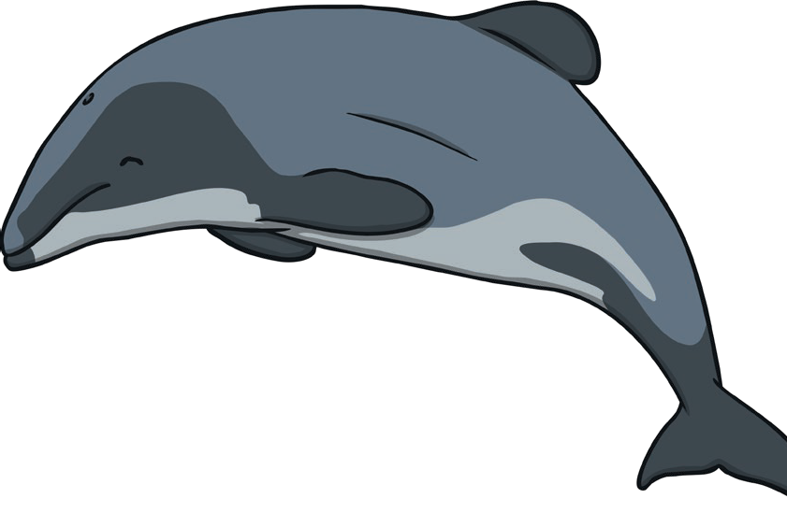

**Mammals**

Are warm-blooded.   
Live on land and in water.   
Have hair or fur.

Have skeletons on the inside of their bodies.

Give birth to live babies which drink their mother’s milk.

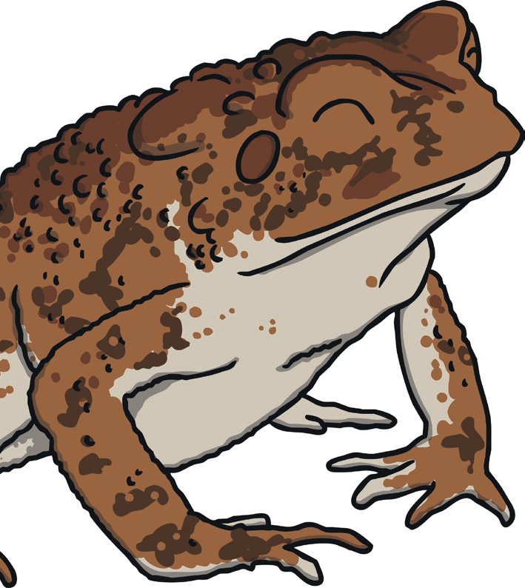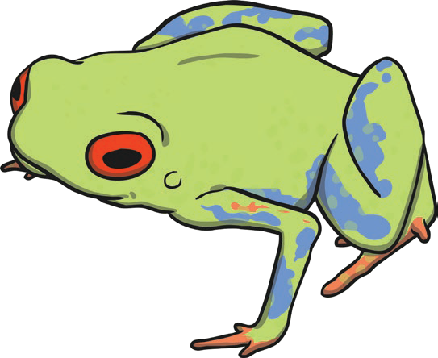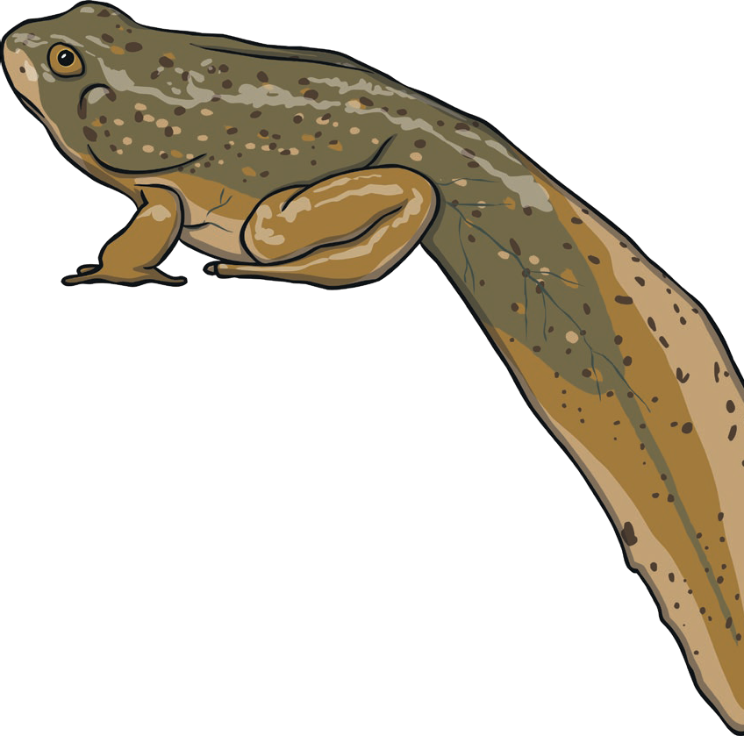

**Amphibians**

Are cold-blooded.

Live on land and in water.

Have moist skin and webbed feet.

Have skeletons on the inside of their bodies. Lay eggs.

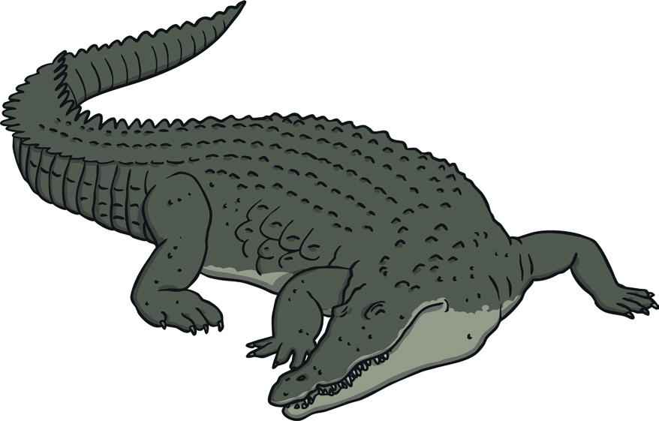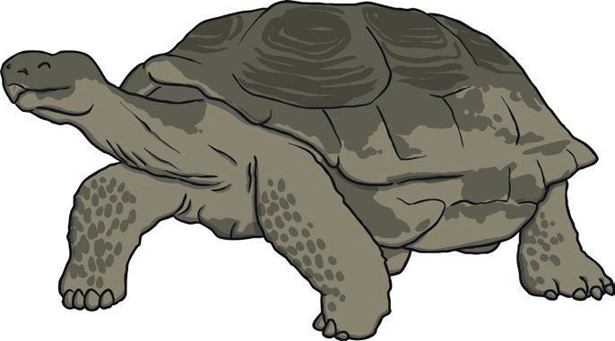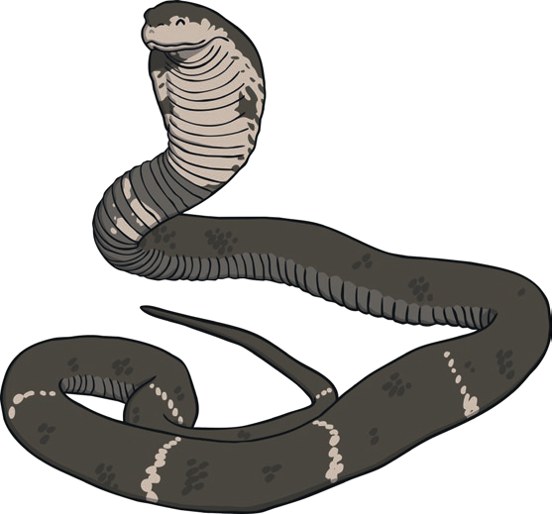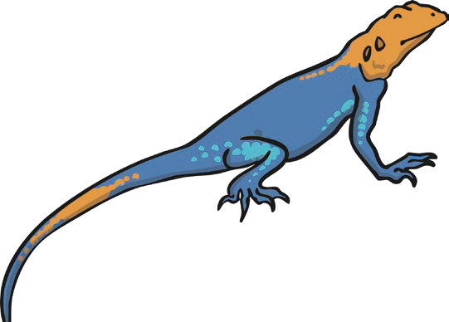

**Reptiles**

Are cold-blooded.

Live on land and in water.

Have scales, ear holes and dry skin.

Have skeletons on the inside of their bodies (but tortoises have one on the outside, too!).

Lay eggs.

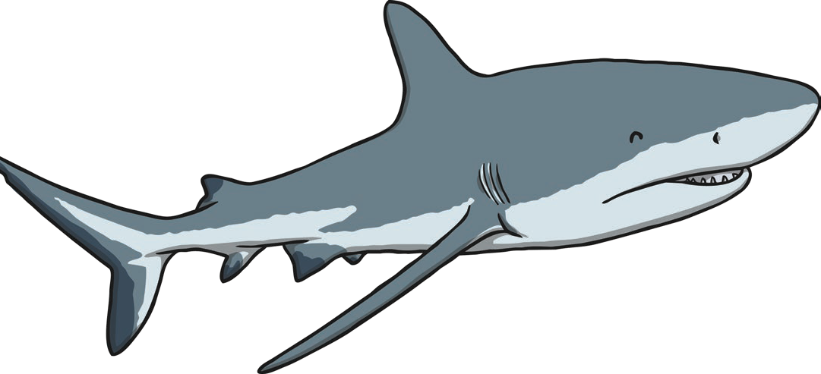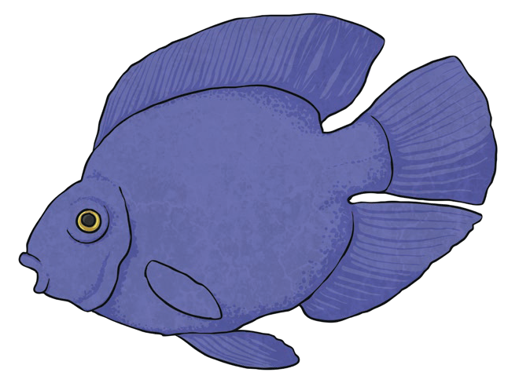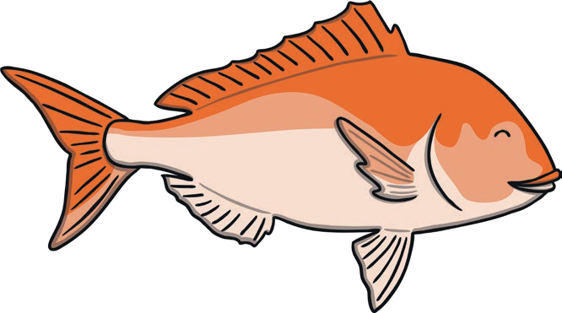

**Fish**

Are cold-blooded. Live in water.

Have fins to move and gills to breathe underwater.

Have skeletons on the inside of their bodies. Lay eggs (in water).

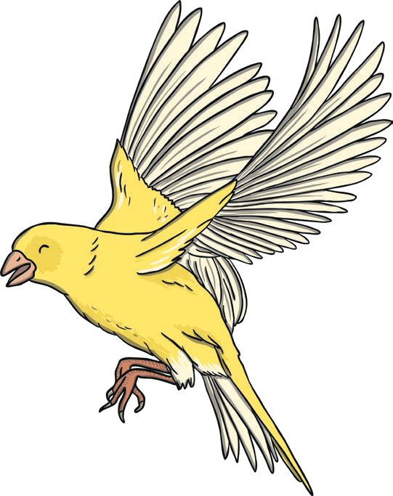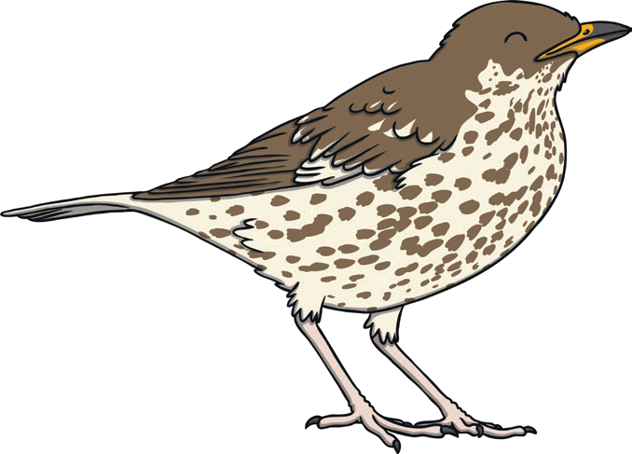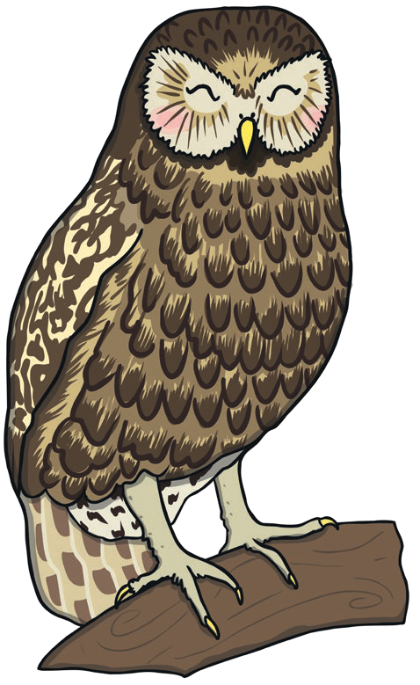

**Birds**

Are warm-blooded.   
Live on land and in water.

Have feathers (unique to birds), wings and a beak.

Have skeletons on the inside of their bodies.   
Lay eggs.