Parent/Carer information leaflet
Your child is being taught to read with Letters and Sounds, a step-by-step synthetic phonics teaching framework. The eBook Library for Letters and Sounds contains 100 books precisely matched to each of the phonics teaching Sets. It means that your child can enjoy reading books that practise the exact grapheme-phoneme correspondences that they have just been taught by their teacher.
How does my child access the eBook Library?
- Go to www.oxfordowl.co.uk
- Click on the ‘Log in’ link (top right) to open the login form.
- Make sure the 'Students' tab is highlighted. Type in the class name and password that your child’s teacher has given your child and click ‘Log in’.
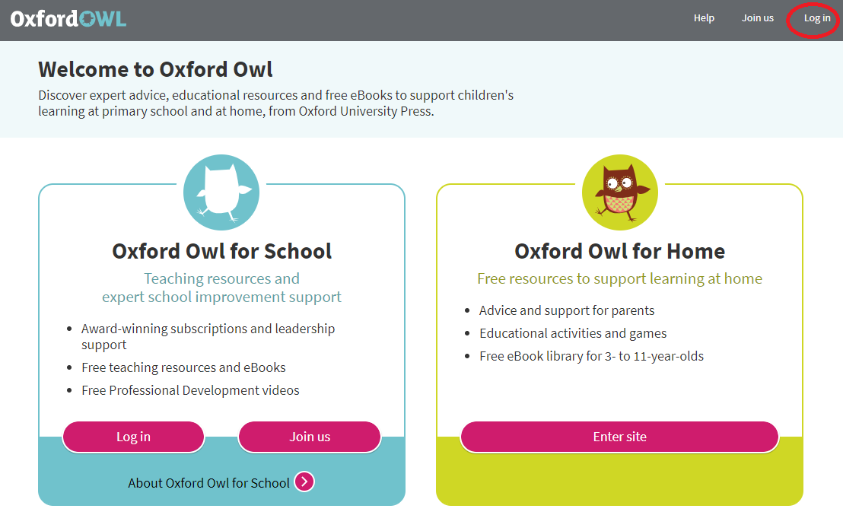
Write your class name and password here:
Class name: year4afs21
Password: Read
- Click on the tile for the eBook Library for Letters and Sounds.
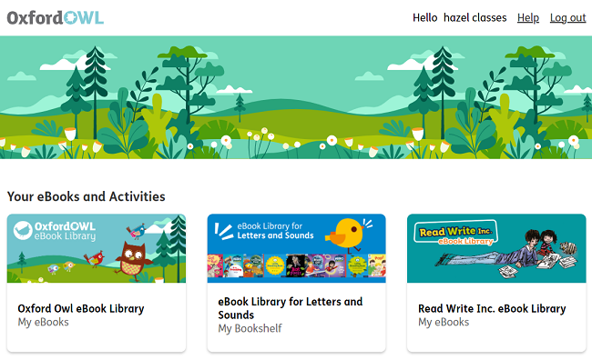
- Click on the eBook to open it.
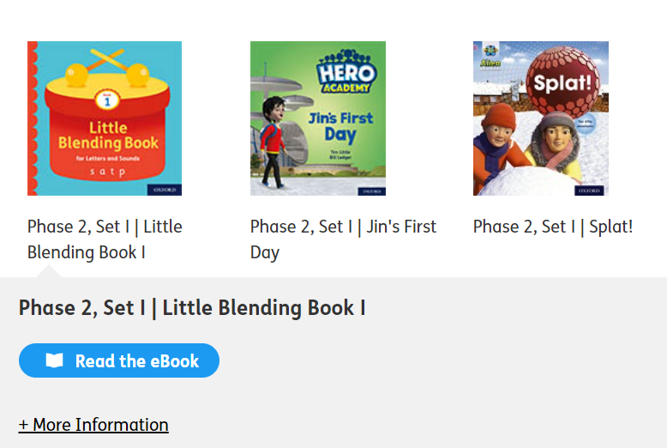
How do I know which book my child should read?
Your child’s teacher will tell them which Set they are working on. Your child can then read any of the books within that Set, as they are all at the same level. However, you might like to start them off with the Little Blending Book (up to Set 14) so that they can practise this important skill before they start reading the rest of the Set.

Alternatively, your child’s teacher may specify an exact title or the grapheme-phoneme correspondences that they want them to practise. You can find this information underneath the book cover in the library.

How do I find the right book or Set?
To find the right Set, click on the Levels filter at the top of the
library, scroll down to Letters & Sounds Phases and select the Set you want.
