Wednesday 8th July
Matching Time Challenge
Now that you have recapped time using o’clock and half past, see if you can remember some more learning from year 1 and earlier on in year 2.

Look at the time intervals in the grid. Can you colour each matching time period in the same colour?

60 seconds
60 minutes
1 month
1 day

12 months
7 days
1 hour
1 year

1 week

1 week
24 hours
about 4 weeks
1 minute
1 week

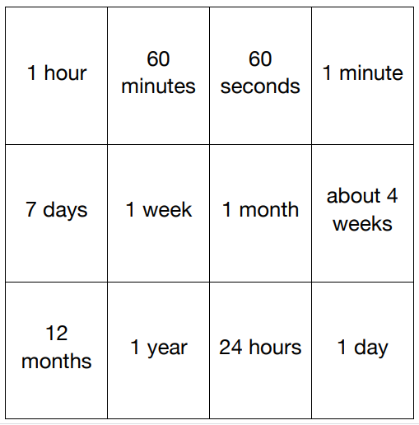
Super Challenge
Using the information above, can you work out the following:
Half and hour = ____________ minutes
2 days = ___________ hours
3 months = about ___________ weeks

