Tuesday 7th July
Temperature challenges
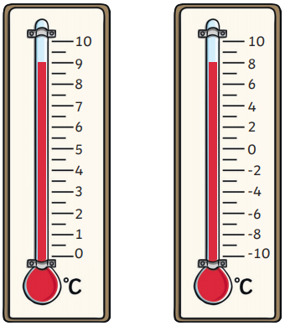
True or False?
These two thermometers show the same temperature?
Explain how you know!
____________________________________________________________________________________________________________________________________________________________________________________________________________________________________________________________________________________________________________________________________

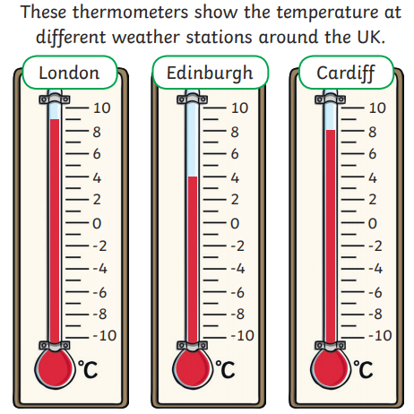

- How many more degrees warmer in London than Cardiff? _____________________

- Belfast is Warmer than Edinburgh but cooler than London.
What could the temperature be in Belfast?___________________________

- Which month do you think these temperatures might have been measured in? Explain your answer_________________________________________________________
___________________________________________________________________
___________________________________________________________________

