Mr. Bell has just called me to say he needs someone clever to help him quick and I knew straight away that you would be the best girl for this job!
He arrived at school this morning to find ALL the hands had fallen off the classroom clocks! Can you help show him how the hands should look on each clock so he can put them back on correctly?
He would also like to know if any classrooms should be having their lunch. This means their clock must show a time between quarter past 12 and 10 past 1. Good luck!

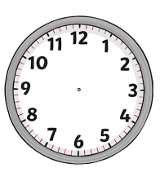
Class 2:
Half past 12
Class 1:
7 o’ clock

Class 10:
Quarter past 11
Class 9:
Quarter to 10

Class 4:
Half past 4
Class 3:
2 o’ clock

Class 6:
Half past 8
Class 5:
Quarter to 5

Class 8:
Quarter to 1
Class 7:
Quarter past 3

