It is Mrs. Shaw and Mrs. Carr who need your help today! They have forgotten the codes for the school safe and ALL of Archibald’s money is trapped inside! If we do not get it out that means we won’t have money for treats and trips next year! Can you help? Please can you solve the 4 calculations below and tell us the two-digit numbers for each colour lock?

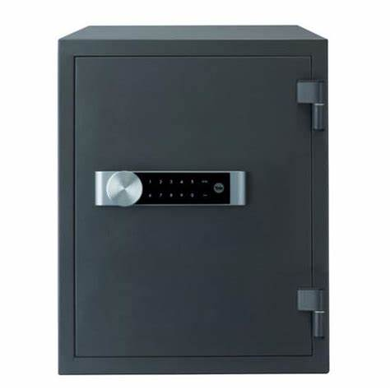

Black Lock
18 ÷ 3 =
Orange Lock:
11 x 5=
Red Lock:
43 – 36 =
Green Lock:
53 + 18 =

Some Handy Hints:
Multiplying: Count up in the multiples you know (2, 3, 5 and 10).
4 x 10 = 10, 20, 30, 40. So = 40

Dividing: Count how many times the smaller numbers go into the larger number.
E.g. 12 ÷ 2 = 2, 4, 6, 8, 10, 12 so 2 goes into 12 6 times so 12 ÷ 2 = 6

Addition: Use column method or drawing dienes.
Drawing dienes

2 1 + 3 5

= = 56
Column method. 21 + 35

T O
2 1
+ 3 5
Add ones: 6
Add tens: 5 0
Add together: 5 6

Subtracting: Crossing out dienes
Draw the dienes for the first, largest number.
24 - 13 =

Then, cross out the number of tens and ones in the second number. For 13, you need to cross out 1 ten stick and 3 ones. The answer is what you have left.
If you don’t have enough ones to subtract, you may need to exchange a ten stick for ten ones first before crossing any out.

