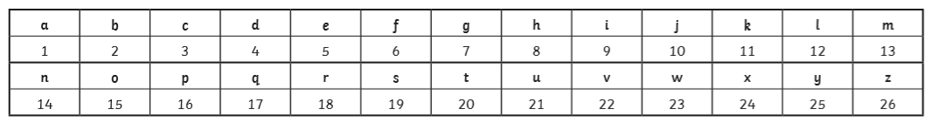
Crack the Code!
Miss. Pearson has a joke for you:
What does a cloud wear under his raincoat?
Can you solve the calculations below to solve the answer? Good luck! Maybe you could write your own favourite joke back to Miss. Pearson too, she loves a good giggle.

5 x 4 16 ÷ 2 44- 23 7 x 2 40 ÷ 10 25 ÷ 5 6 x 3 8 +5+3 10 ÷ 10 7 x 2 5 x 4 27 – 8

Can you write your best joke for Miss. Pearson?

________________________________________________________________________________________________________________________________________________________________________________________________

