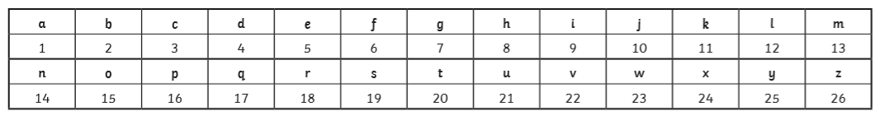
Crack the Code!
Year 2 have a joke for you:
What does a cloud wear under his raincoat?
Can you solve the calculations below to solve the answer? Good luck! Maybe you could write your own favourite joke back to the staff too, they love a good giggle.

5 x 4 16 ÷ 2 24- 3 7 x 2 2 x 2 25 ÷ 5 6 x 3 8 + 5 + 3 10 - 9 7 x 2 5 x 4 27 – 8

Can you write your best joke for Miss. Pearson or Mr. Bourke?

________________________________________________________________________________________________________________________________________________________________________________________________

