Oh no! The Office staff have locked all the school’s money in their safe! Can you crack the code to help them get it out?

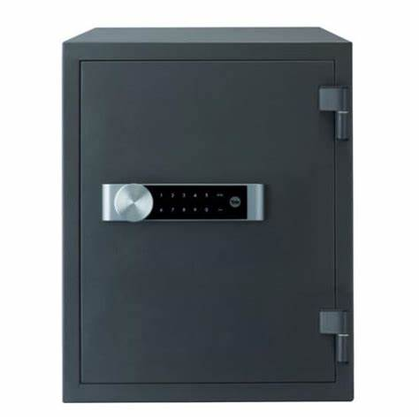

Black Lock
28 ÷ 2 =
Orange Lock:
9 x 5 =
Red Lock:
59 – 6 =
Green Lock:
26 + 12 =

Code: ___ - ___ - ___ - ___
Some Handy Hints:
Multiplying: Count up in the multiples you know (2, 3, 5 and 10).
4 x 10 = 10, 20, 30, 40. So = 40

Dividing: Count how many times the smaller numbers go into the larger number.
E.g. 12 ÷ 2 = 2, 4, 6, 8, 10, 12 so 2 goes into 12 6 times so 12 ÷ 2 = 6

Addition: Use skipping rope method or drawing dienes.
Skipping Rope
(always add your ones first)

T O T O
2 1 + 3 5 = 56

Drawing dienes

2 1 + 3 5

= = 56

Subtracting: Crossing out dienes
Draw the dienes for the first, largest number.
24 - 13 =

Then, cross out the number of tens and ones in the second number. For 13, you need to cross out 1 ten stick and 3 ones. The answer is what you have left.

