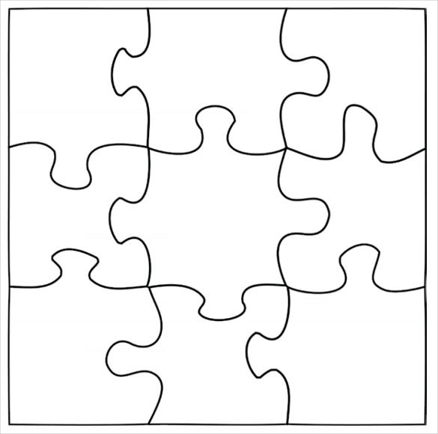
How well can I think about all the different qualities which make up me as a person?

