Monday 6th July 2020
How well can I answer questions using my inference skills?
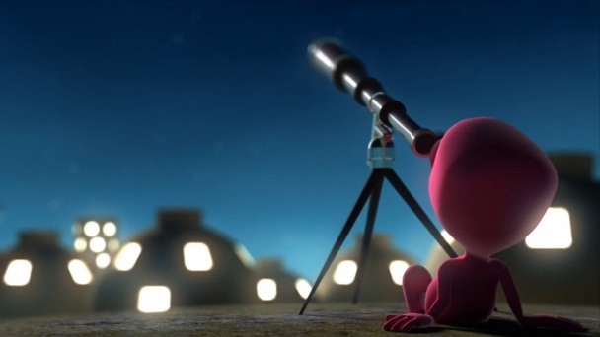
Now that you have watched the story of Blue and Pink Alien use your inference skills to answer these questions to show us what you think the story is about.

- Where is Blue Alien? What clues are there to let you know where he is?
____________________________________________________________________________________________________________________________________________________________

- Why do you think Blue Alien is there?
____________________________________________________________________________________________________________________________________________________________

- Why does Blue Alien go into the sewer and how did he know it was there?
________________________________________________________________________________________________________________________________________________________________________________________________________________

- Who is Pink Alien, where is she and why does Blue Alien contact her?
________________________________________________________________________________________________________________________________________________________________________________________________________________

- Is there anything you noticed about the story that you want to write about?
____________________________________________________________________________________________________________________________________________________________

