Date___________ How well can I use my inference skills to answer questions about a picture?
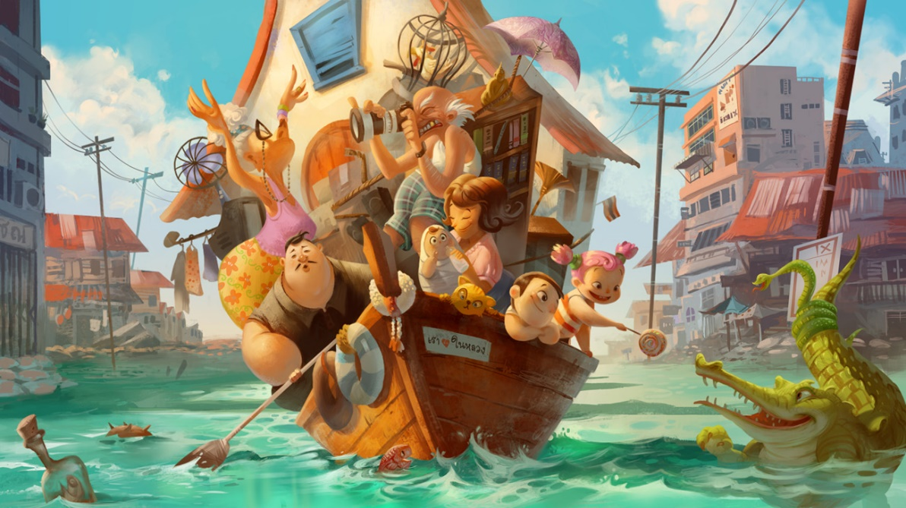

- Why are all of these people on the boat?
- What has happened?
- How do they feel about it?
- How did they manage to get so much onto the boat (including a house!)?
- Where do you think this is? Why?
- Why aren’t there any other boats?

_________________________________________________________________
_________________________________________________________________
_________________________________________________________________
_________________________________________________________________
_________________________________________________________________
_________________________________________________________________
_________________________________________________________________
_________________________________________________________________
_________________________________________________________________
_________________________________________________________________
_________________________________________________________________
_________________________________________________________________
_________________________________________________________________
_________________________________________________________________

