Lesson 1:
How well can I describe the scene at the start of the mystery story?

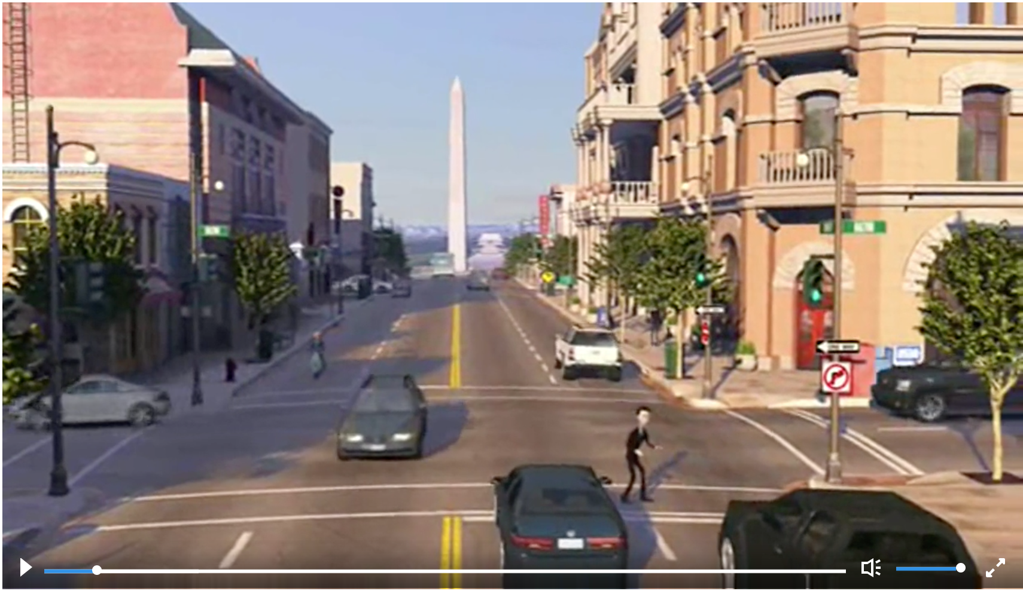

__________________________________________________________________________________
__________________________________________________________________________________
__________________________________________________________________________________
__________________________________________________________________________________
__________________________________________________________________________________
__________________________________________________________________________________
__________________________________________________________________________________

How well can I describe the character Walter Beckett?











