The Great Fire of Newcastle and Gateshead
In October 1854, a gigantic explosion killed 53 people and wiped out many of the buildings which today would have made the Quayside a listed, historic riverfront.
So huge was the explosion which preceded the Newcastle blaze that it was heard as far away as Hartlepool, while people in North and South Shields thought it was an earthquake!
Among the victims was Alexander Dobson, the son of famous Newcastle architect John Dobson.
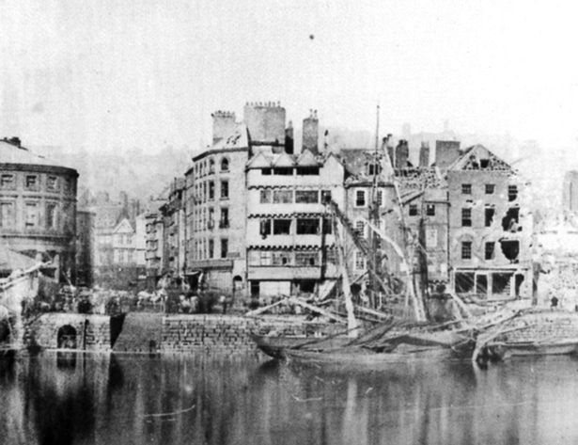
The great fire of Newcastle 1854

What was described at the time as a “most terrible and appalling catastrophe” began in the early hours of October 6th when fire broke out in a worsted manufactory on the Gateshead side of the riverfront.
The building was packed with wool and a quantity of oil which produced a fierce blaze.
Next door was a 100-yard long warehouse containing 130 tons of nitrate of soda, 3,000 tons of brimstone, 170 tons of manganese and one-and-a-half tons of naptha. These chemicals are very flammable, it was a ticking timebomb!
As the warehouse caught fire, blue flames soared skywards as firemen and soldiers of the 26th Regiment fought the inferno.
By this time Newcastle Quayside was packed with spectators, who no doubt felt perfectly safe with the Tyne between them and the spectacle on the opposite bank.
The Newcastle side was densely packed with heavily populated alleys and streets, people came out in excitement to watch the event!
Then came the giant explosion, which sent fireballs of sulphur, brimstone, stones and metal across the river.
This sent the people watching on the Newcastle side into panic. They tried to get away, running in every direction. Some were hit by flames and stones, some suffocated from smoke and fumes and many were injured in the chaos.
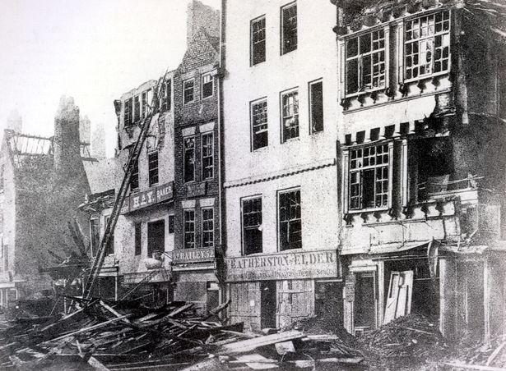
The great fire of Newcastle 1854

The fire in Gateshead had spread to a vinegar works, timber yard, a flour mill, and homes.
On the Newcastle side the flames took hold in houses, a stationer’s and draper’s and the Dun Cow pub whose stock of spirits further fuelled the flames.
It spread rapidly to the Grey Horse Inn, the Sun Inn, and tenement buildings.
Newcastle issued a plea for help and fire engines arrived from Sunderland, Hexham, Durham, Morpeth and Berwick.
Today, a regenerated Newcastle Quayside is a leisure and business boom area.
But the Quayside story could have been very different had disaster not struck in 1854.
We would have been left with a waterfront with many 17th Century features.

