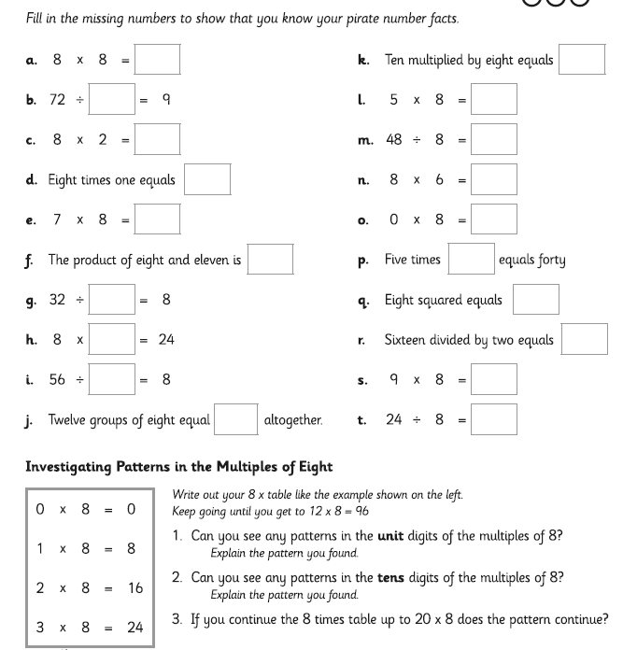
Date___________ How well can I multiply and divide by 8?

__________________________________________________________________________________
__________________________________________________________________________________
__________________________________________________________________________________
__________________________________________________________________________________
__________________________________________________________________________________
__________________________________________________________________________________
__________________________________________________________________________________
__________________________________________________________________________________
__________________________________________________________________________________
__________________________________________________________________________________
__________________________________________________________________________________
__________________________________________________________________________________

