Friday 10th July 2020
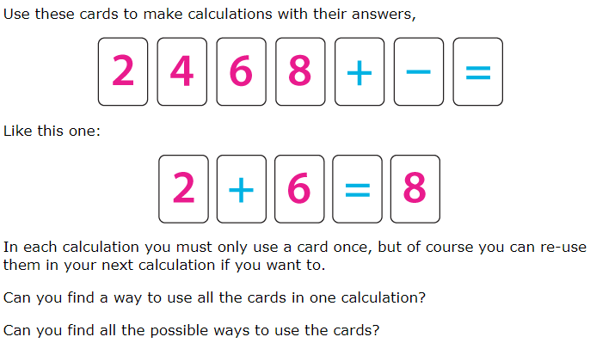
2, 4, 6, 8 Challenge

