Monday 6th July 2020
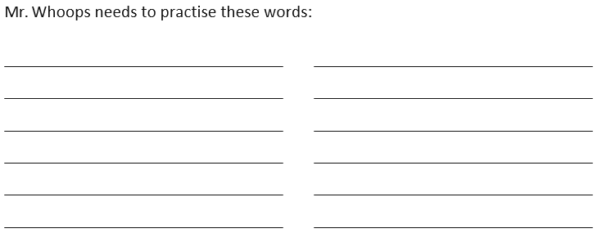
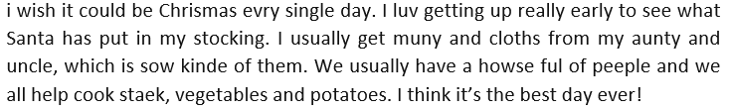
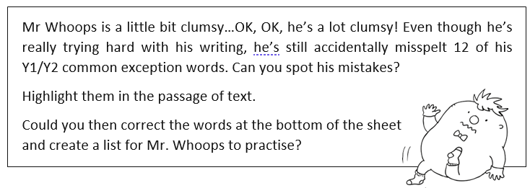
Spellings – spotting mistakes in Common Exception Words
Now have a go at correcting these sentences

- The teacher opened the classroom dor.
___________________________________________________________

- There were wyld animals in the story.

___________________________________________________________

- “Howld the balloon tight,” said mum.

___________________________________________________________

