[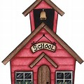](https://www.bing.com/images/search?q=School+Clip+Art&FORM=IRTRRL)[](https://www.bing.com/images/search?q=School+books&FORM=IRIBEP)

**A**

**R**

**C**

**H**

**I**

**B**

**A**

**L**

**D**

**F**

**I**

**R**

**S**

**T**