How well can I recognise and find human and physical features in the United Kingdom?
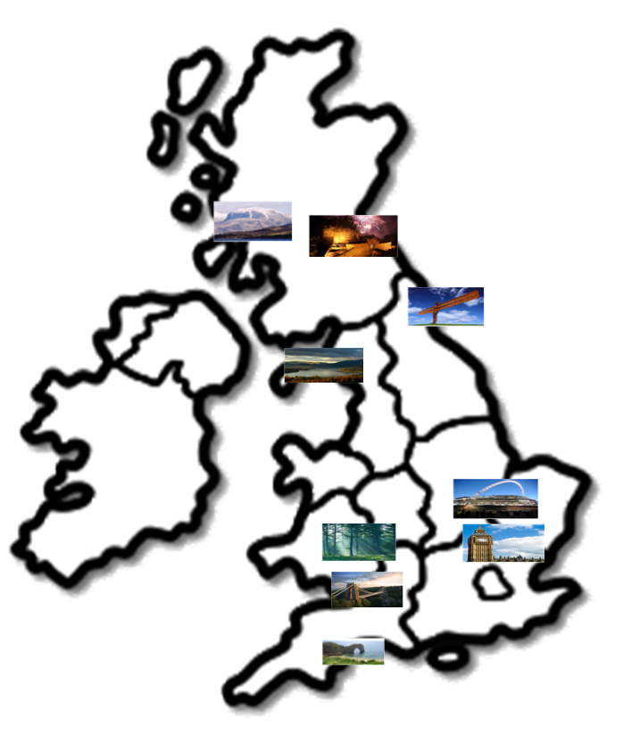
Here are some landmarks in the United Kingdom. Look at their names in the table below and use them to label the pictures on the map. You might be able to label some landmarks straight away but others might need a bit of research!
Once you have labelled a landmark you can tick the ‘where are they?’ box. Then ask yourself, which are human features and which are physical features? Write your answer in the table!
Landmark | Ben Nevis | Edinburgh | Angel of the North | Lake Windermere | Wembley Stadium | Big Ben | Forest of Dean | Clifton Suspension Bridge | Durdle Door
Where are they?

Human or physical feature?

