?
Who is to blame for the Great Fire of London?

Welcome to the courtroom. I am Judge ____________________________
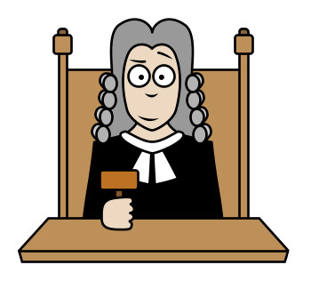
I find the first defendant, Thomas Farriner _________________________ because _______________________________________________________________
______________________________________________________________________________________________________________________________

Your punishment: (if applicable) ______________________________________
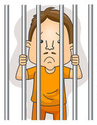

I find the second defendant, King Charles __________________________ because _______________________________________________________________
______________________________________________________________________________________________________________________________

Your punishment: (if applicable) ______________________________________

I find the third defendant, Mayor Bludworth _______________________ because _______________________________________________________________
______________________________________________________________________________________________________________________________

Your punishment: (if applicable) ______________________________________
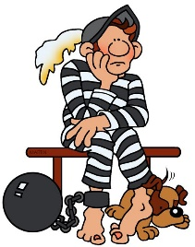

I find the final defendant, Samuel Pepys ___________________________ because _______________________________________________________________
______________________________________________________________________________________________________________________________

Your punishment: (if applicable) ______________________________________
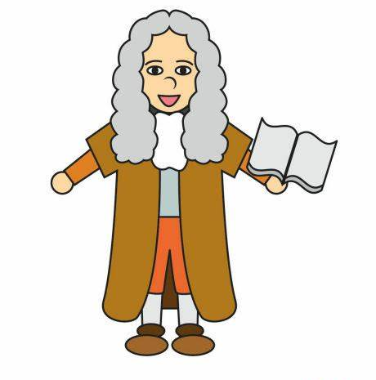

Challenge: To make my decisions I used the following sources of evidence:
____________________________________________________________________________________________________________________________________________________________________________________________________________________________________________________________
I believe the most reliable source of evidence was
______________________________________________________________
because
______________________________________________________________________________________________________________________________

