Wednesday Numeracy Challenge
Finding a half in lots of different ways

- How many different ways of colouring ½ can you find?

- What about these shapes?
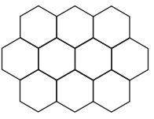
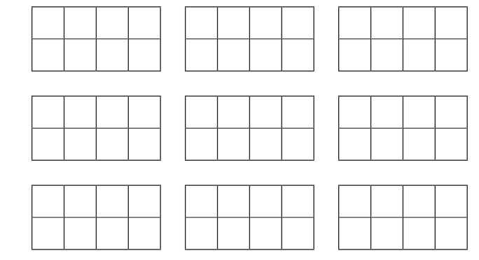

How do you know that you have shaded ½? Explain your reasoning.
____________________________________________________________________________________________________________________________________________________________________________________________________________________________________________________________

