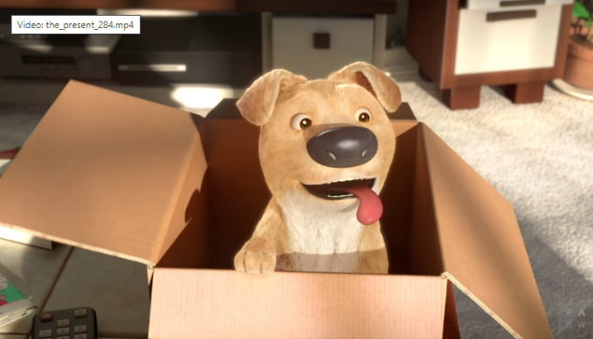
Wednesday 10th June 2020
How well can I write a letter?
In your work I am looking for:
- Your writing set out in a letter format
- Use of the 4 different sentence types
- 3 clearly organised paragraphs
- Capital letters and full stops
- Your letters formed correctly and joined where possible

____________________________________________________________________________________________________________________________________________________________________________________________________________________________________________________________________________________________________________________________________________________________________________________________________________________________________________________________________________________________________________________________________________________________________________________________________________________________________________________________________________________________________________________________________________________________________________________________________________________________________________________________________________________________________________________________________________________________________________________________________________________________________________________________________________________________________________________________________________________________________________________________________________________________________________________________________________________________________________________________________________________________________________________________________________________________________________________________________________________________________________________________________________________________________________________________________________________________________________________________________________________________________________________________________________________________________________________________________________________________________________________________________________________________

