Working with Dinosaurs
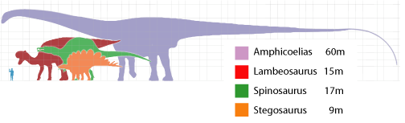
Here are the lengths of several different dinosaurs:
Can you answer the questions below using the information that you have been given?
1. Which dinosaur is the longest?
2. Which dinosaur is the shortest?
3. How much longer is the Lambeosaurus than the Stegosaurus?
4. How much shorter is the Spinosaurus than the Amphicoelias?
5. Which two dinosaurs have a total length of 32m?
Super Challenge
- Can you research the lengths of some other dinosaurs and make up your own questions about them?
Can you find out the weight of these dinosaurs (or others is you prefer) and write some facts comparing the weights of different dinosaurs?
____________________________________________________________________________________________________________________________________________________________________________________________________________________________________________________________
____________________________________________________________________________________________________________________________________________________________________________________________________________________________________________________________
_______________________________________________________________

