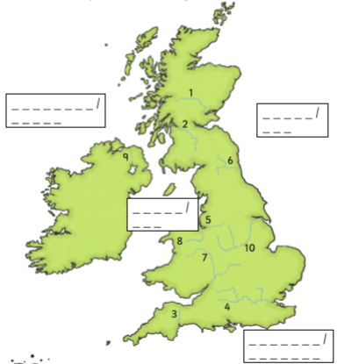Date_________ How well can I locate the rivers and seas of the UK?

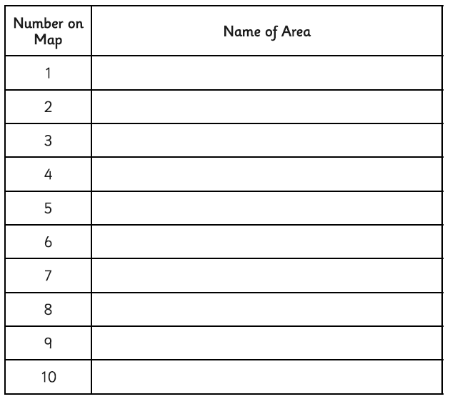

Use an atlas or a map to locate these ten rivers and write them next to the correct number. You also need to find the names of the four seas of the UK and write them on your map.

Thames Mersey

Severn Tyne

Trent Clyde

Tay Dee

Bann Exe