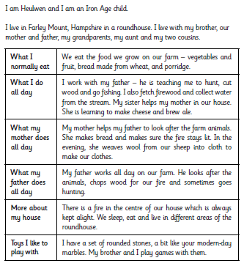
How well can I compare my life in the UK with the life of an Iron Age child in the UK?

Draw a picture of your life and an Iron Age child’s life.

Similarities
__________________________________________________________________________________
__________________________________________________________________________________
__________________________________________________________________________________
__________________________________________________________________________________
__________________________________________________________________________________
__________________________________________________________________________________

Differences
__________________________________________________________________________________
__________________________________________________________________________________
__________________________________________________________________________________
__________________________________________________________________________________
__________________________________________________________________________________
__________________________________________________________________________________

