Shaping It
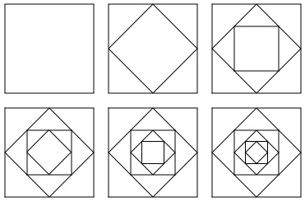

These pictures were made by starting with a square, finding the half-way point on each side and joining those points up. This creates a smaller shape (which also happens to be a square) inside the original. The half-way points of this new shape are then joined up to make a third shape. This way of making new shapes is continued until it gets too small to do properly.
You can start with any straight-lined shape.
Here's one where I've coloured each new halving line to help to see what has happened more clearly.
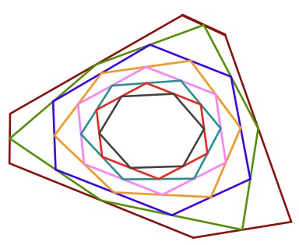

So, it's your turn to have a go.
It's good to start with a large shape as it's going to get smaller and smaller each time.
Which shapes will you try?
Are any shapes easier than others?
Are there any shapes that do not work?

