PSHE How well can I cope with feeling angry?

Think about the video you have just watched. Unfortunately, we can call get a bit angry sometimes. What are some useful ways that help you to remain calm?
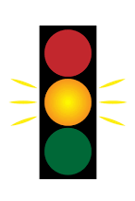
What could you do to move from red to amber? How can you move from amber to green? What helps you to stay at green? Write your strategies around the traffic light. You could even include some snazzy pcitures to show exactly what you mean!

