Thursday 18th June 2020
Observation – How well can I describe how heat changes different food items?
Look closely at what happens when the following items are heated up. How do they change in appearance and texture? Have any changed from a solid to a liquid?
Ask your grown up to help you cool these items back down. Which two go back to how they were (they might be a different shape) which are changed forever?
Item | Observations on how it changed | Changed forever or goes back to how it was?
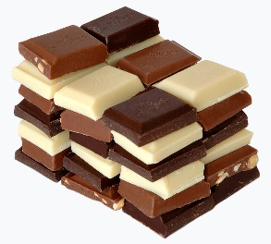

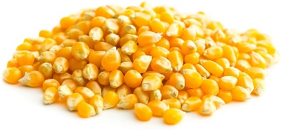

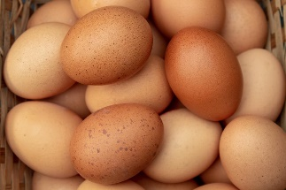

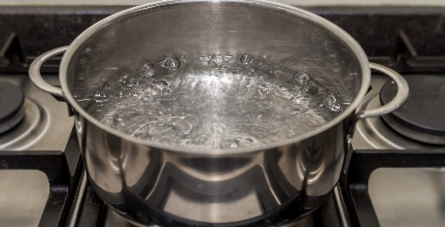
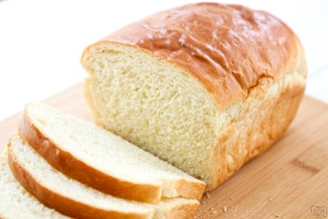

Challenge – heating and cooling are the opposite processes of one another. Can you think of any other opposites that we use in science?

