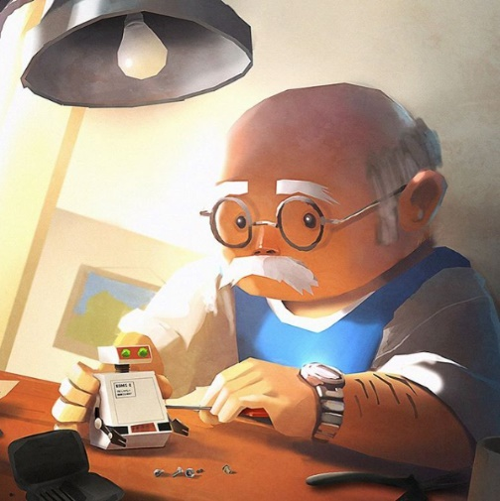
The Robot Maker!

- What does this robot do?
- Is the man building it or repairing it?
- How does he feel about it? Is this one special?
- Do you think he’s been a robot maker for a long time?
- Is he good at his job?
- What kind of person do you think he is? What are his likes/dislikes? Do you think he prefers to be around people, or be alone?

_________________________________________________________________
_________________________________________________________________
_________________________________________________________________
_________________________________________________________________
_________________________________________________________________
_________________________________________________________________
_________________________________________________________________
_________________________________________________________________
_________________________________________________________________
_________________________________________________________________
_________________________________________________________________
_________________________________________________________________
_________________________________________________________________
_________________________________________________________________
_________________________________________________________________
_________________________________________________________________
_________________________________________________________________
_________________________________________________________________
_________________________________________________________________

