Boys and girls, you will have seen lots of these titles in your books before. When you have completed your letter, can you tick off what you have remembered to do?
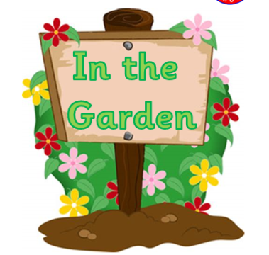
w/c Monday 22nd June 2020.
How well can I write a letter to Mrs Ward or Mr Morrow?
I have used capital letters in the right places.
I have used full stops in the right places.
I have used a spelling mat to check tricky words.
I have used the suffixes I have been taught – ing, ed, er.
I have set my letter out correctly.*

*Does your letter have…
- Your address in the top right corner?
- The date?
- Dear…?
- The reason you’re writing?
- 2 short paragraphs of more detail?
- Conclusion/question?
- From…?

