Spot the mistake…
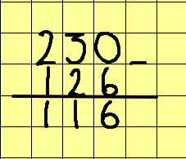
What has the child done wrong when using the column method for subtraction?

David went to a football match and estimated that there were 4367 supporters in the ground.
When the official announcement was made there were 5912 supporters. What was the difference between David’s estimate and the actual total? When full, the ground holds 6712. How many empty seats were there?

Spot the mistake…
What has the child done wrong when using the column method for subtraction?
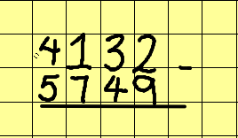

How should it look and what is the answer?

