TH

The Daily Gazette.

The fire that is currently tearing through the streets of London.

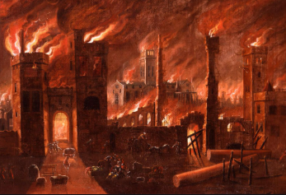ThewT

Terror filled the streets of London today as an unstoppable fire tore through the town, burning down any house that stood in its path. It is believed the fire started in a bakery on Pudding Lane in the early hours of Sunday morning because the owner of the bakery, Thomas Farriner, did not ensure all the fires were completely out. This is something he strongly denies. The fire has now been burning bright for over 24 hours and it shows no signs of stopping as it heads down Watling Street towards St. Pauls Cathedral.

_______________________________________________________________________________________________________________________________________________________________________________________________________________________________________________________________________________________________________________________________________________________________________________________________________________________________________________________________________________________________________________________________________________________________________________________________________________________________________________________________________________________________________________________________________________________

London is today glowing red as a great fire has spread through our streets, turning buildings to ash. It is also believed some people may have lost their lives, although this has not been confirmed. People tried to save their homes by throwing water onto the fire, however a strong wind has helped the fire to spread quicker and further. One witness said she saw the wood of her house burn to the ground in a matter of minutes and said she did not have time to save her personal belongings as she had been banned from bringing her cart near to the fire. There is widespread panic throughout London and the people are looking to King Charles for help, as Mayor Bloodworth has so far took little action. Thomas Farriner is being blamed by many for this disaster as they believe the fire started in his bakery. He today gave a statement saying “It is awful what is happening here in London but I can say with certainty that all the fires in my bakery were put out properly before I went to bed. I cannot be blamed for this!” We do not know how the fire started but what we do know is that London needs a leader to help stop this fire in its tracks.

______________________________________________________________________________________________________________________________________________________________________________________________________________________________________________________________________________________________________________________________________________________________________________________________________________________________________________________________________________________________________________________________________________________________________________________________________

**London’s Burning!**

Monday 2nd September 1666 By Miss. Pearson