LO: How well can I make inferences about a book?
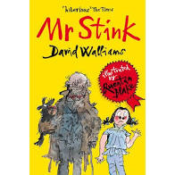
Date ____________
- What do you think this book will be about?
- Who do you think Mr Stink is?
- What kind of character do you think he will be?
- Do you think this story will be like any others that you have read?
- Have you read any books written by David Walliams?
- What type of book do you think this will be?

Read chapter one, then consider the following quote:
No one was really friendly to Mr Stink. No one stopped for a chat.
At least, not until the day that a little girl finally plucked up the courage to speak to him – and that’s where our story begins.
“Hello,” said the girl, her voice trembling a little with nerves.

What does this tell you about the character of the girl, Chloe?

