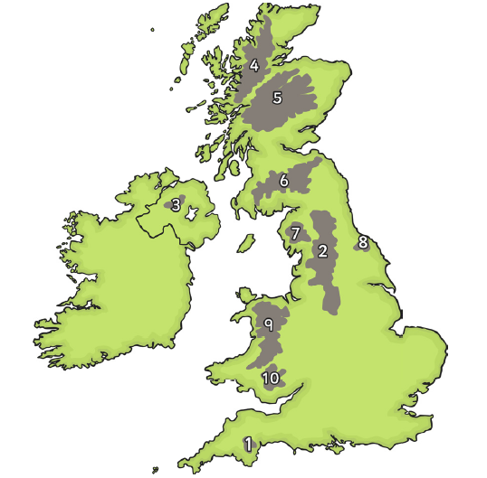
Date_________ How well can I locate the hills and mountains of the UK?
Here are the ten areas you are looking for:
Northwest Highlands
Dartmoor
Cambrian Mountains
Southern Uplands
Brecon Beacons
Sperrin Mountains
Cumbrian Mountains
North Yorkshire Moors
Pennines
Grampian Mountains

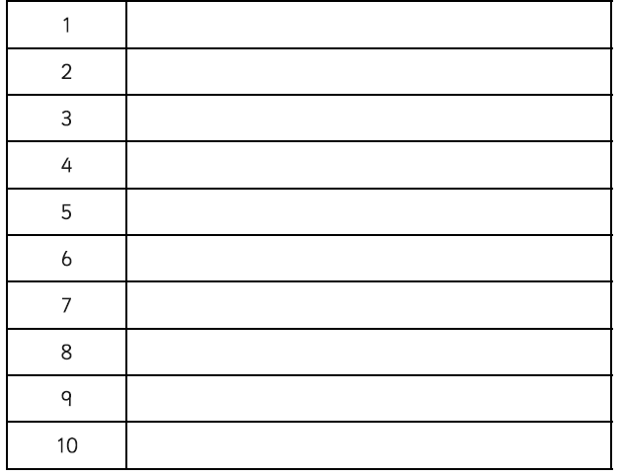
Write the name of the area next to the correct number.
Challenge:
Can you use an atlas to find out the highest peak of each of these areas?

