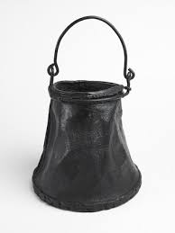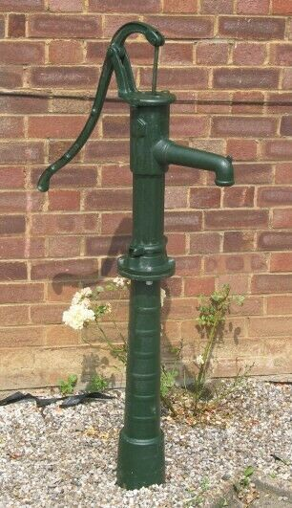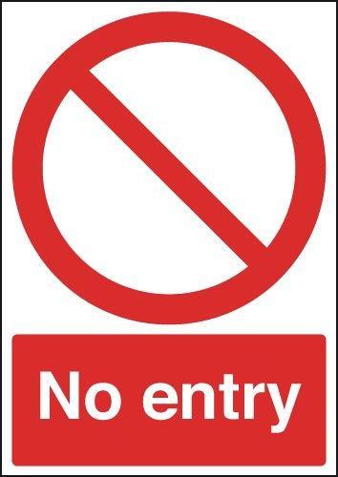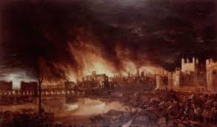

Those fighting the fire had trouble getting through to the blaze.

Fire fighting equipment was no match for a serious fire.

Water supplies were low.

There were very few rules to say how or where houses could be built.

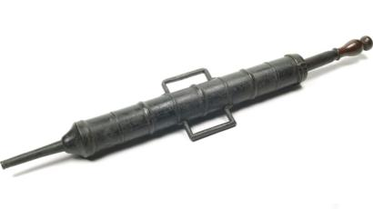

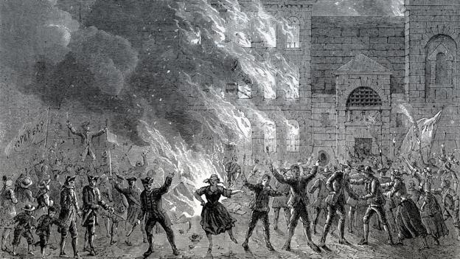

The streets were crowded with people trying to save their belongings.

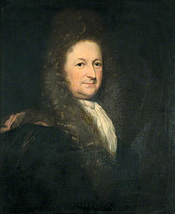

London’s Mayor was slow to take action- fires often broke out in London.

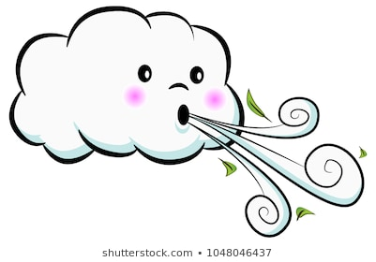

There was a very strong wind the night of the fire.

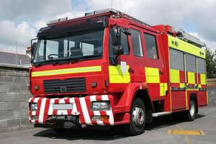

There was no fire service in 1666.

No Rules

[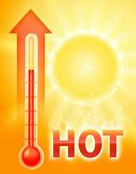](about:blank)

The summer of 1666 was very hot and dry!

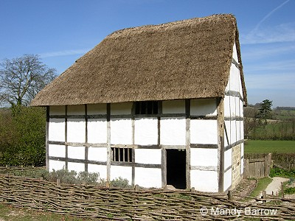

Many houses were made from wood and straw.

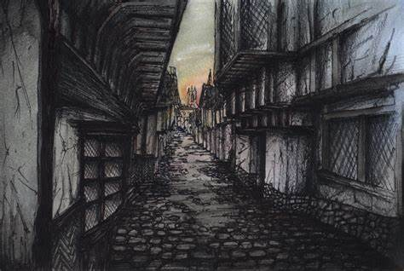

There were many narrow streets with houses close together.

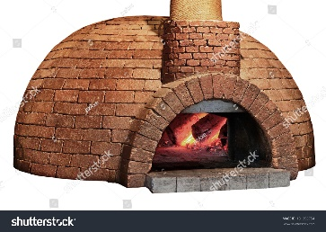

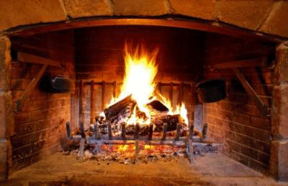

Candles were used for light and open fires for cooking.

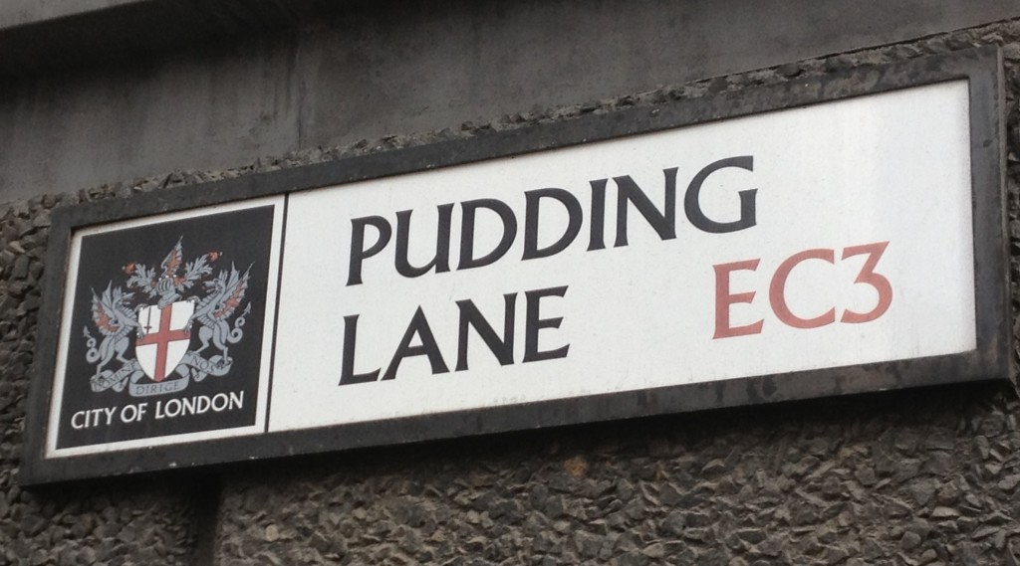

In Pudding Lane, Thomas Farriner went to bed without putting out the fire that heated the oven.

Sparks from the baker’s oven on Pudding Lane fell to the floor and set fire to the house.