My Great Fire of London

Waterfall Booklet

By _____________________

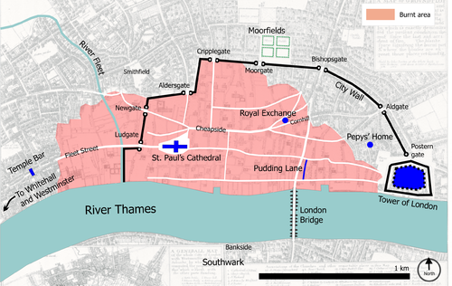

**Words I need to know and use!**

**Cause:**

**Consequence:**

**Flammable:**

**Disaster:**

**Rebuild:**

Key Vocabulary and Maps

River…

Important People

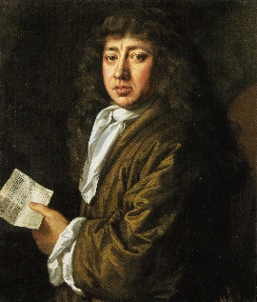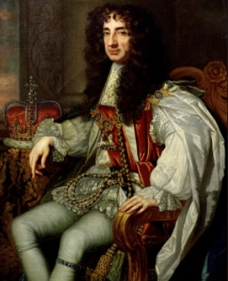

Thomas Farriner ________________________________________________________________________________________________________________________________________________________________________________________________________________________

King Charles ||_______________________________________________________________________________________________________________________________________________________________________________________________

Samuel Pepys _______________________________________________________________________________________________________________________________________________________________________________________________________________

Thomas Bludworth ________________________________________________________________________________________________________________________________________________________________________________________________________________________

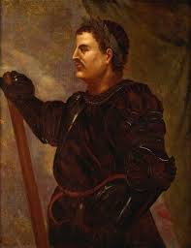

**2nd September 1666 (Sunday):** _______________________________________________

___________________________________________________________________________

**3rd September 1666 (Monday):** ______________________________________________

___________________________________________________________________________

**4th September 1666 (Tuesday):** ______________________________________________

___________________________________________________________________________

**5th September 1666 (Wednesday):** ___________________________________________

___________________________________________________________________________

**6th September 1666 (Thursday):** _____________________________________________

___________________________________________________________________________

Key Events

**My Fact Catcher!**

**Questions I have!**

Questions and Research