How well can I research significant people from the past?

Can you carry out your own research and find out the significant role each person below had in the Great fire of London?

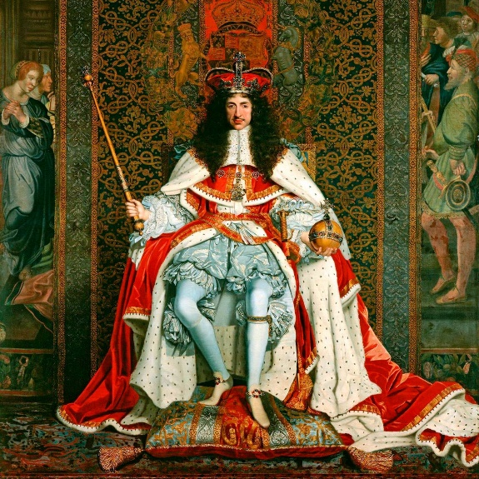

King Charles II

I was **significant** because _______________________________ ________________________________________________________________________________________________________________________________________________________________________________________________________________

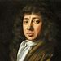

Samuel Pepys

I was **significant** because _______________________________ ________________________________________________________________________________________________________________________________________________________________________________________________________________

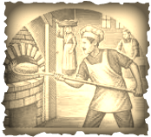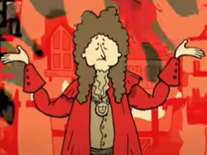

Thomas Farriner

I was **significant** because _______________________________ ________________________________________________________________________________________________________________________________________________________________________________________________________________

Mayor Bludworth

I was **significant** because _______________________________ ________________________________________________________________________________________________________________________________________________________________________________________________________________