Wallpaper
These pieces of wallpaper need to be ordered from smallest to largest.
Can you find a way of doing it?
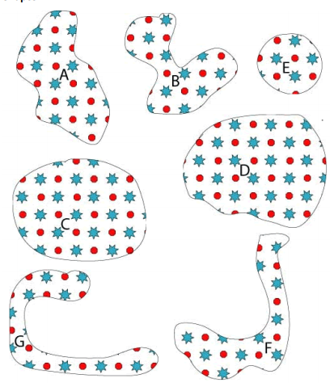

Can you explain how you did it?
___________________________________________________________________________________________________________________________________________________________________________________________________________________________________________________________________________________________________________________________

