Date____________ How well can I investigate how shadows change when the distance between the light source and the object changes?
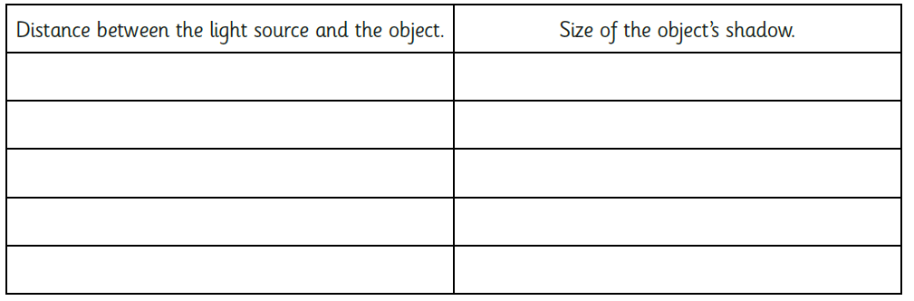
What patterns do you notice? What conclusions can you make?

_________________________________________________________________
_________________________________________________________________
_________________________________________________________________
_________________________________________________________________
_________________________________________________________________
_________________________________________________________________
_________________________________________________________________
_________________________________________________________________

