Lesson 3 – Year 4
How well can I use a range of speech verbs and adverbs to show how the characters are speaking?
Use a thesaurus to help you find speech verbs and adverbs for each animal. Then write a sentence for each one using direct speech. The first one has been done for you.

Animal | Direct Speech
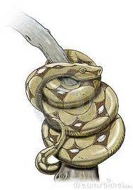 | The snake murmured wearily into the man’s ear, “My family has lived in this tree for years and years.”  Quietly, the snake murmured into the man’s ear, “My family has lived in this tree for years and years.”

