Lesson 3 – Year 3
How well can I use a range of speech verbs to show how the characters are speaking?
Use a thesaurus to help you find speech verbs for each animal. Then write a sentence for each one using direct speech. The first one has been done for you.

Animal | Direct Speech
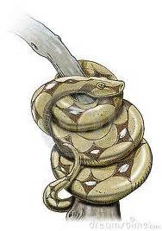 | The snake murmured into the man’s ear, “My family has lived in this tree for years and years.”

