How to make Salt Dough Nature Impressions
This recipe will help you to make your very own salt dough. You can then create your own nature impressions!
Materials
- 1 cup salt
- 1 cup plain flour
- Up to 1 cup of water
- Rolling pin
- String/Ribbon
- A selection of leaves

Method:
- Combine the salt and flour, then pour in the water gradually, stopping when it has become dough-like and not too sticky. There should be no residue left on your fingers when you touch it.
- Knead it on a floured surface for a few minutes to make it soft, workable and stretchy, like you would with any dough.
- Taking smaller sections of the dough, flatten each out like a pancake, until 1cm thick. You could also roll it out and use a round cutter to make individual pieces if you like.
- Poke a straw through the centre, near the top, of each shape, so that ribbon can be threaded through later.
- Then see this site to learn how to make your impressions:https://theimaginationtree.com/coloured-salt-dough-leaf-impressions/
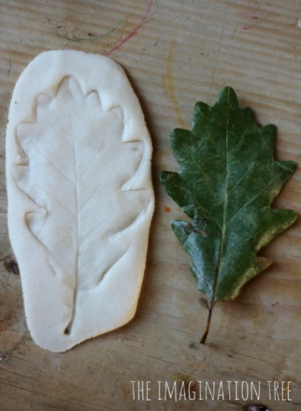
When you are finished, add string or ribbon to complete your decoration. Why not hang your decorations on one of the local positivi-trees? We can’t wait to see pictures!

