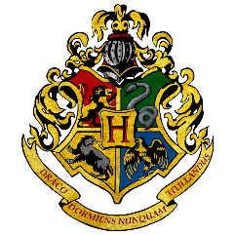
HOGWARTS SCHOOL
of WITCHCRAFT and WIZARDRY
HEADMASTER: ALBUS DUMBLEDORE
(Order of Merlin, First Class, grand Sorcerer, Chf.Warlock, Supreme Mugwump,
International Confed. of Wizards)

I am pleased to inform you that you have been accepted at the Hogwarts School of Witchcraft and Wizardry. Unfortunately, due to Corona Virus you are unable to come to school at this time, this is by no means a reflection of your abilities as a witch or wizard.
Therefore, in the meantime, students are requested to complete a series of challenges to prove their abilities. This will enable the sorting hat to decide which house you belong to once school reopens.
To avoid detection by muggles please complete the series of challenges with the support of family members only! You do not want to receive a letter from the Ministry of Magic and detained in Azkaban for misusing magic.
Once you have completed the challenges, or for further information and advice, use your electronic devices (no magic please) to share your success with one of our undercover witches. You can contact them at homework@archibald.newcastle.sch.uk or via Twitter or the Facebook page.
Good luck young witches and wizards. You have two weeks!

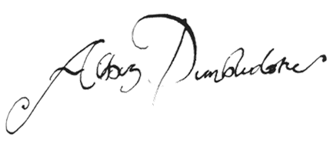

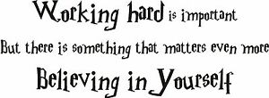

Potions class 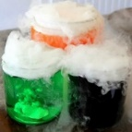  Professor Snape was the potions master … Can you make a potion to turn evil Lord Voldemort into a cute fluffy bunny rabbit? Please write me a list of ingredients in the order you put them in. | Astronomy  At Hogwarts you will study the stars. Spend some time looking at the stars in the sky. Can you find any patterns?  Look for Scorpius.  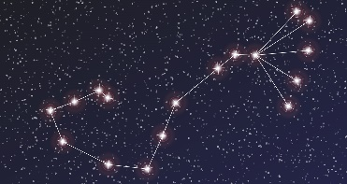
Care of magical creatures  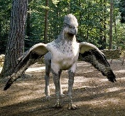  This is a Hippogriff – it is part bird and part horse. Draw and label your own magical creature.  What makes it magical? | defence against the dark arts  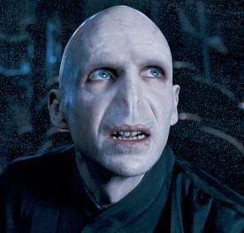  If your magic wand breaks you will be left with no way to fight Voldemort and the Death Eaters. Create a trap to capture Voldemort. Please send us information about how it would work so we can send your creation to the Ministry of Magic to be checked.
The great hall  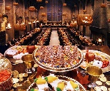  Students eat their meals in the Great Hall . Plan a feast that you would like to eat when you come back to school. Create a ‘Hogwarts’ menu, like you get in a restaurant. | Spells and charms  Make a happiness spell. What would you put in a cauldron to make the world happy?  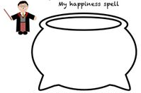
The houses  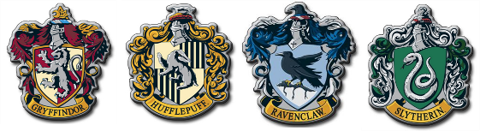  Each house has a different emblem. Make a new crest and give it a name. Think about the name you will give it. | Invisibility cloak  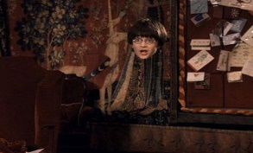  Harry Potter had an invisibility cloak that helped him sneak around the castle. Write some sentences and tell me what you would do if you were invisible for the day.

Wanted  Voldemort is a dark wizard. He was very evil. Can you make a Wanted poster to tell people about him and what to do if they find him.  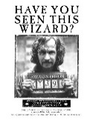 | Hagrid  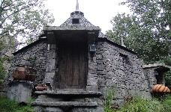Hagrid is half giant nut lives in small hut on the edge of the forest. Can you design a new house for him? Describe it so that Filch can build him a new one.
Owl post  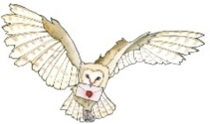At Hogwart’s you send your letters by post. Write a letter to someone you haven’t seen in a very long time… send it in the post. It will definitely make them happy. | Dragon egg  Make your own dragon egg.  You can boil an egg and decorate it or even paper mache, if your adults are feeling brave.  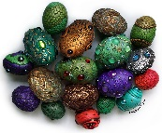
Dobby  Dobby is a house elf who has to do what his masters tell him even if he doesn’t want to. What things would you ask Dobby to do for you? Make a list. | The dark forest  Imagine you are walking through the dark forest. What can you, see, smell, hear and feel? Write a description.  Be warned – if you do not follow the rules at Hogwart’s, you may have to do detention here!
The marauder’s map  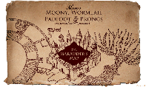  Harry, Hermione and Ron use a secret map to get around the school. Create a map to help you get around when you come back to school. | Herbology  Students at Hogwarts have to pot mandrakes, which are used to make special healing potions. If you can, plant your own seed, watch it grow. What does a plant need to grow?  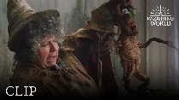
The castle  The castle is a wonderful magic home to witches and wizards. Research castles around the world. Make a list of the castles and where to find them. Can you find them on a map?  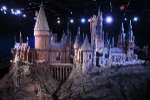 | Well done Witches and Wizards! You are all amazing Year 2 and we really do miss you!

