Friday Spelling Task
Homophones

Homophones are words that are spelt differently, have different meanings but sound the same.
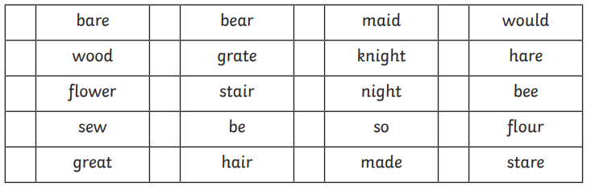
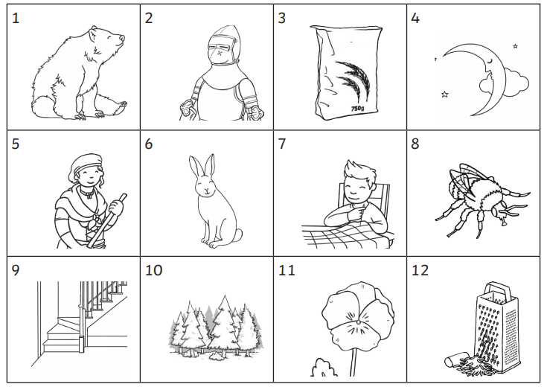
Can you match the correct homophone to the pictures below?
Now complete these sentences by neatly crossing out the incorrect homophone.

- Last night/knight I went for a walk in the moonlight.
- Blew/blue is my favourite colour.
- If you want to go on holiday, you’ll have to catch a plane/plain.
- I brush my hair/hare every day.
- I am over here/hear.

