Order, Order!
Have a look at the sets of four quantities below. Can you rank them in order from smallest to largest?
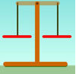
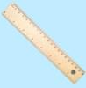
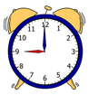
To help you decide, you may need to find extra information or carry out some experiments.
Can you convince us that your order is right? Prove it!
Convince me;  _______________________________________________________________________________________________________________________________________________________________________________ | Time  Taken to travel to school  For mustard and cress to grow from seeds  Taken to eat a biscuit  Between your 6th and 7th birthdays
Convince me;  _______________________________________________________________________________________________________________________________________________________________________________ | Distance  You could jump up in the air  You can kick a football  You can run in half a minute  Length of a bug
Mass
Of a blown-up balloon
Of a bar of chocolate
Of a loaf of bread
Of your teacher
Convince me;
_______________________________________________________________________________________________________________________________________________________________________________

