Date________ How well can I use an atlas to locate cities of the United Kingdom?
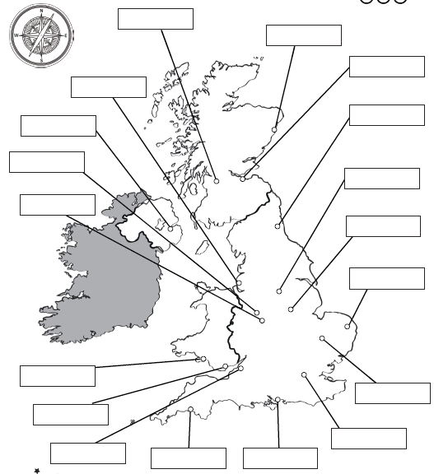
Aberdeen Belfast Birmingham Bristol Cambridge Cardiff
Edinburgh Glasgow Liverpool London Newcastle Norwich
Nottingham Plymouth Portsmouth Sheffield Swansea Wolverhampton

