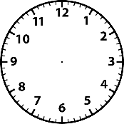

__________________________________________________________________

The Bad Tempered __________________

30.6.20 How well can I plan my own version of the Bad Tempered Ladybird?









