Dear Boys and Girls,
Santa has sent me here to keep an eye on you. I do hope we can be great friends and that you will all look after me until it is time for me to go back to the North Pole.

Every morning when you come in try to spy from what hiding place I’ll be keeping an eye. I’ll watch to see if you follow the rules and work really hard whilst you are at school.

I’ll gather the info and write it all down - I do hope nothing makes me frown. Then each night at the end of school off I fly to the North Pole through the dark night sky. I will tell Santa the things that you’ve done. I won’t forget any, not a single one.

Some things make him happy, some things make him cry. Then I’ll be back in the morning before the sun hits the sky. So there you have it, that’s how it’s done as you see it’s the elves that help the North Pole run.

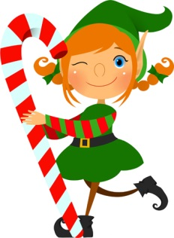
Before we get started there are two rules to know, first, if you touch me I lose my magic and must go. Second, I need a name and it must come from you so get started thinking on your favourite one or two.

Remember to be good and spread lots of cheer, Merry Christmas and a Happy New Year!

Love Elf

